**EMMI *ORU* Cerner Reqs**

**Solicited by ORM**

**Version 1.3**

**Prepared By: Sarah Thies & Tom Fredrickson**

**Date: 3/5/2019**

[Document Control 3](#_Toc500326414)

[Resources 3](#_Toc500326415)

[Project Distribution List 3](#_Toc500326416)

[Document Version Control 3](#_Toc500326417)

[1. Introduction 4](#_Toc500326418)

[1.1 Purpose 4](#_Toc500326419)

[1.2 Project Scope 4](#_Toc500326420)

[1.3 Terminology Standards 4](#_Toc500326421)

[1.3.1 Acronyms 4](#_Toc500326422)

[1.3.2 Glossary 4](#_Toc500326423)

[1.4 Document References 4](#_Toc500326424)

[2. Diagram 5](#_Toc500326425)

[3. Requirements 6](#_Toc500326426)

[3.1 Functional Requirements (Cerner FSI and Cloverleaf) 6](#_Toc500326427)

[3.2 Non-Functional Requirements 6](#_Toc500326428)

[3.3 Messaging Protocols 6](#_Toc500326429)

[3.3.1 Inbound to BayCare Cloverleaf 7](#_Toc500326430)

[3.3.2 Outbound to the BayCare Cloverleaf 7](#_Toc500326431)

[3.3.3 Inbound to the Vendor 7](#_Toc500326432)

[3.3.4 Outbound to the Vendor 7](#_Toc500326433)

[3.3.5 Inbound to the BayCare Cerner EMR 7](#_Toc500326434)

[3.3.6 Outbound BayCare Cerner to Cloverleaf 8](#_Toc500326435)

[4. HL7 Messaging 8](#_Toc500326436)

[4.1 Messaging Format 8](#_Toc500326437)

[4.1.1 Segments 8](#_Toc500326438)

[4.1*.*2 Messaging Event Types 8](#_Toc500326439)

[4.1*.*3 Cloverleaf Configuration Files 9](#_Toc500326440)

[4.1.4 Cloverleaf Site Location 9](#_Toc500326441)

[4.2 Data Transformation Requirements 9](#_Toc500326442)

[4.3 Sample Messages 10](#_Toc500326443)

[5. Testing 12](#_Toc500326444)

[5.1. Unit Testing Scenarios 12](#_Toc500326445)

[5.2 Integrated Testing Scenarios 12](#_Toc500326446)

[5.3 Testing Approvals 13](#_Toc500326447)

[5.4 Piloting 13](#_Toc500326448)

[5.5 Approvals - Please see Monica Bousbar in the Lab 14](#_Toc500326449)

[6. Deployment / Implementation Model 14](#_Toc500326450)

[Appendix A: Risks and Concerns 14](#_Toc500326451)

[Appendix B: Issues List 14](#_Toc500326452)

# **Document Control**

## Resources

|  |  |  |
| --- | --- | --- |
| **Name** | **Role** | **Email** |
| Thies, Sarah | BayCare FSI Developer | Sarah.Thies@baycare.org |
| Fredrickson II, Thomas | BayCare Cloverleaf Developer | Thomas.Fredrickson@baycare.org |
| Patel, Chirayu | BayCare Sr. Systems Analyst | [Chirayu.Patel@baycare.org](file://BCAD/DATA/USERS/b104994/Staging%20Requirements/Bryan.Gwozdz@BayCare.org) |
| Marshall, Abbie | BayCare Systems Analyst | Abbie.Marshall@baycare.org |
| Gwozdz, Bryan | BayCare Sr. Systems Analyst, Data Warehouse & Business Intelligence | [Bryan.Gwozdz@BayCare.org](mailto:nicole.gitney@baycare.org) |
| Gitney, Nicole | BayCare Director Nursing Informatics | [nicole.gitney@baycare.org](mailto:bcook@emmisolutions.com) |
| Cook, Brian | EMMI Interface Specialist | [bcook@emmisolutions.com](mailto:sryzner@emmisolutions.com) |
| Rabkin, Dana | EMMI Project Manager | drabkin@emmisolutions.com |
| RYZNER, SZYMON | EMMI Product Manager | [sryzner@emmisolutions.com](https://wiki.ucern.com/display/public/reference/Unit+10i+-+Result+and+Document+Processing+Inbound) |
|  |  |  |
|  |  |  |

## Project Distribution List

## Document Version Control

|  |  |  |  |
| --- | --- | --- | --- |
| **Version** | **Date** | **Modifier** | **Description** |
| V1.0 | 11/10/2016 | Sarah Thies | Originally Created |
| V1.1 | 2/6/2017 | Tom Fredrickson | Added Cloverleaf Components |
| V1.2 | 3/7/2017 | Sarah Thies | Added Note about killing Rebounds in NFR Section |
| V1.3 | 03/05/2019 | Charles Markwardt | Added new Contributor system |
|  |  |  |  |

# 1. Introduction

## 1.1 Purpose

The purpose of this document is to provide details on the **added** build of the ORU results interface that supports the EMMI Application

## 1.2 Project Scope

The scope of the integration includes Cerner orders outbound to EMMI and the associated results returned inbound to Cerner. The data will flow through Cloverleaf. This document is focused on EMMI **results** only. The result messages will use the **existing** GetWell Network Results Inbound Interface to Cerner.

## 1.3 Terminology Standards

### 1.3.1 Acronyms

MLLP – Minimum Lower Layer Protocol for messaging framing a HL7 message.

GWN: Get Well Network

### 1.3.2 Glossary

List the terms that require definition

## 1.4 Document References

**Cerner Specifications:**

[https://wiki.ucern.com/display/public/reference/Unit+10i+-+Result+and+Document+Processing+Inbound](mailto:Chirayu.Patel@baycare.org)

**EMMI Documents/Specifications:**

# 2. Diagram

***Results*** by Cerner Order



# 3. Requirements

## 3.1 Functional Requirements (Cerner FSI and Cloverleaf)

Provide detail for the below functional requirements. The message transformation requirements for the components defined in this specification should be specified in section 4.2 of this document.

|  |  |  |
| --- | --- | --- |
| **Cerner** |  |  |
| **Number** | **Requirement Name** | **Requirement Description** |
| FR.2017.1.0 | CPI | The BayCare CPI value will be sent via Cloverleaf in field PID-3 with identifier type in sub-field 5 containing value BCCPI. The CPI value sent is used for load balancing among the four ***new*** ESI Servers |
| FR.2017.2.0 | FIN | The BayCare FIN value will be sent via Cloverleaf in field PID-18.1 with identifier type in field PID-18.5 containing value BMGFN. |
| FR.2017.3.0 | HNAM\_ORDERID | For the inbound results to complete the order, the assigning authority subfield, ORC 2.2 and OBR 2.2 for the placer order id must contain the value ***HNAM\_ORDERID***. |
| FR.2019.4.0 | Contributor Systems | GETWELL Contributor system is to support the Baycare Heatlh Systems organization and the EMMIHI contributor system is to support the Ambulatory Care Coordination organization. The contributor source for both systems is Invision. |

## 3.2 Non-Functional Requirements

Provide concise detail for the below non-functional requirements. The below requirements must be evaluated for every project.

|  |  |  |
| --- | --- | --- |
| **Cerner** |  |  |
| **Number** | **Requirement Name** | **Requirement Description** |
| NFR.2017.1.0 | EMMI Activity Type | Cloverleaf will kill results rebounding out of Cerner when OBR-24 contains OFC Videos (The EMMI Activity Type) |
| NFR.2017.2.0 | EMMI Results | Vanja will be aliasing EMMI Results on the Outbound Tab to DONOTSEND to help in blocking rebounds. |
|  |  |  |

## 3.3 Messaging Protocols

Below are listed the details for the messaging protocols that will be leveraged for this integration. Please see the reference document located on the Integration SharePoint server: <insert link to document here>

### 3.3.1 Inbound to BayCare Cloverleaf

Production

IP: 10.5.250.201

Port: 23248

Test

IP: 10.5.250.203

Port: 23248

### 3.3.2 Outbound to the BayCare Cloverleaf

### 3.3.3 Inbound to the Vendor

Click here to enter text.

### 3.3.4 Outbound to the Vendor

* Click here to enter text.

### 3.3.5 Inbound to the BayCare Cerner EMR

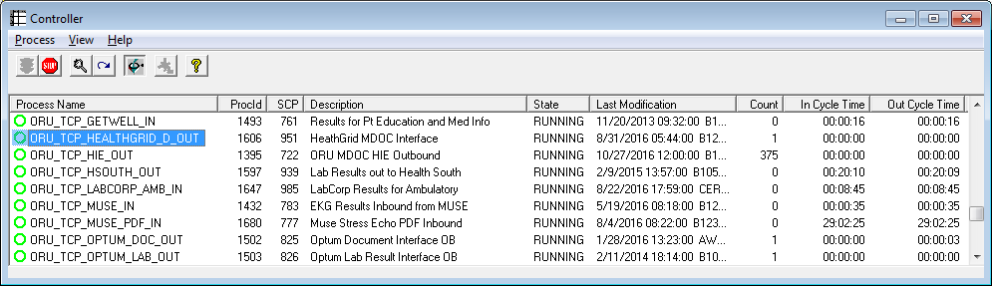

***Note:*** The Inbound Com Server ORU\_TCP\_GETWELL\_IN will load balance result messages for both the GWN & EMMI among the following ESI servers based on CPI.

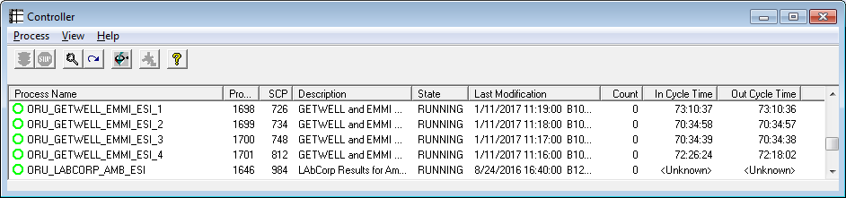

**C30**

Port Number: 10056

**P30**

Port Number: 10056

### 3.3.6 Outbound BayCare Cerner to Cloverleaf

# 4. HL7 Messaging

## 4.1 Messaging Format

HL7 v. 2.3, cerner\_emr ORU\_R01

### 4.1.1 Segments

The segments utilized for the ORU interface are:

MSH

PID

[PV1]

{

ORC

OBR

[{NTE}]

*Message Construction Notes:*

*[Square Brackets] – Optional*

*{Curly Brackets} – Repeatable*

*MSH – Message Header*

*EVN – Event segment*

*PID – Patient ID segment*

*PV1 – Patient Visit segment*

*ORC – Common Order segment*

*IN1 – Insurance segment*

*[{ – Start of optional, repeatable group*

*}] – End of optional, repeatable group*

### 4.1*.*2 Messaging Event Types

Below is the messages type necessary for this integration

|  |  |
| --- | --- |
| **Event Type** | **Description** |
| ORU^R01 | Result |
|  |  |

### 4.1*.*3 Cloverleaf Configuration Files

Pre-Proc: tpsAdvHL7Filter.tcl

{ADVFLTR {

{{PATH {MSH:3}} {VALUE {{KEEPALIVE}}} {MATCHDISP KILL} {NOMATCHDISP CONTINUE}}

}} {DEBUG 0}

Xlate File: emmi\_cerner\_oru.xlt

-------------------------------------------

Bulk Message Copy then blanking out the following:

PID-3.2, PID-18.2, PID-18.3, PID-18.4

Copy “BCCPI” 🡪 PID-3.5

Copy PID-18.4 🡪 PID-18.5

### 4.1.4 Cloverleaf Site Location

Site: patient\_ed\_11

**Results**

**C30**

SITE: **patient\_ed\_11\_p**& THREAD: **oru\_cer\_out**

**P30**

SITE: **patient\_ed\_11\_p**& THREAD: **oru\_cer\_out**

## 4.2 Data Transformation Requirements

|  |  |  |  |  |  |
| --- | --- | --- | --- | --- | --- |
| **Field Description** | **HL7 Field Loc.** | **Required Y/N** | **Data Type** | **Length** | **Notes** |
| Patient Identifier Type – **load balancing** | PID-3.1 | Y | ID | 20 | CPI value is used to **route** messages from Cerner inbound com server to NEW ESIs |
| Patient Identifier Type | PID-3.5 | Y | ID | 20 | Value is BCCPI to identify the CPI number |
| Patient Account Number | PID-18.1 | Y | ID | 20 | Cerner FIN value |
| Patient Account Number Type | PID-18.5 | Y | ID | 20 | Value is BMGFN to identify the FIN number |

## 4.3 Sample Messages

**Cerner**

**Inbound Cerner *Result*:**

MSH|^~\&|GWN|GWN|HNAM|BAYCARE|20170120103619||ORU^R01|20170120103619222|T|2.3

PID|1||810008950^^^^BCCPI||EMMI^TEST||19570118|F||||||||||2983643^^^^BMGFN

ORC|RE|8761156551^HNAM\_ORDERID|ES20170120103616-888||||||||||||20170120103504290||EMMI SOLUTIONS

OBR|1|8761156551^HNAM\_ORDERID|ES20170120103616-888|EMMIEDU|||201701201035|||||||||||||||201701201036|||F

OBX|1|ST|EMMIEDU^Education||COPD: ABOUT||||||F

OBX|2|ST|EMMICOMPDATE^Emmi Completed Date||||||||F

OBX|3|ST|EMMIEXPDATE^Emmi Expiration Date||Feb 19, 2017||||||F

OBX|4|ST|EMMIEVENT^Emmi Message Event||Scheduled||||||F

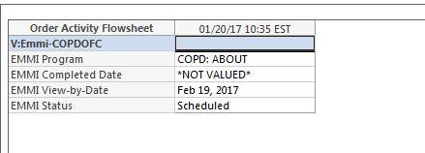

MSH|^~\&|GWN|GWN|HNAM|BAYCARE|20170120104228||ORU^R01|20170120104228914|T|2.3

PID|1||810008950^^^^BCCPI||EMMI^TEST||19570118|F||||||||||2983643^^^^BMGFN

ORC|RE|8761156551^HNAM\_ORDERID|ES20170120103616-888||||||||||||20170120103504290||EMMI SOLUTIONS

OBR|1|8761156551^HNAM\_ORDERID|ES20170120103616-888|EMMIEDU|||201701201035|||||||||||||||201701201042|||F

OBX|1|ST|EMMIEDU^Education||COPD: ABOUT||||||F

OBX|2|ST|EMMICOMPDATE^Emmi Completed Date||Jan 20, 2017||||||F

OBX|3|ST|EMMIEXPDATE^Emmi Expiration Date||Feb 19, 2017||||||F

OBX|4|ST|EMMIEVENT^Emmi Message Event||Completed||||||F

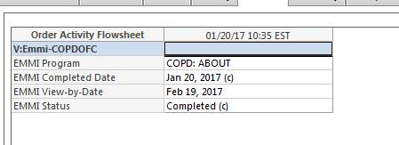

**I** for ***In Progress*** sent OBR-25 because no Completed Date available to send *(i.e. patient hasn't viewed it yet)*

This configuration to send In Progress was reviewed because this status cannot be canceled and the clinical team ***accepted*** it.

MSH|^~\&|GWN|GWN|HNAM|BAYCARE|20170120104942||ORU^R01|20170120104942984|T|2.3

PID|1||810008950^^^^BCCPI||EMMI^TEST||19570118|F||||||||||2983643^^^^BMGFN

ORC|RE|8761156225^HNAM\_ORDERID|ES20170120104940-959||||||||||||20170120104827937||EMMI SOLUTIONS

OBR|1|8761156225^HNAM\_ORDERID|ES20170120104940-959|EMMIEDU|||201701201048|||||||||||||||201701201049|||**I**

OBX|1|ST|EMMIEDU^Education||ACUTE LOW BACK PAIN||||||F

OBX|2|ST|EMMICOMPDATE^Emmi Completed Date||||||||F

OBX|3|ST|EMMIEXPDATE^Emmi Expiration Date||Feb 19, 2017||||||F

OBX|4|ST|EMMIEVENT^Emmi Message Event||Scheduled||||||F

C:\Users\b104994\AppData\Local\Temp\msohtmlclip1\02\clip_image003.jpg

**F** for final sent when completed date available

MSH|^~\&|GWN|GWN|HNAM|BAYCARE|20170120105406||ORU^R01|20170120105406323|T|2.3

PID|1||810008950^^^^BCCPI||EMMI^TEST||19570118|F||||||||||2983643^^^^BMGFN

ORC|RE|8761156225^HNAM\_ORDERID|ES20170120104940-959||||||||||||20170120104827937||EMMI SOLUTIONS

OBR|1|8761156225^HNAM\_ORDERID|ES20170120104940-959|EMMIEDU|||201701201048|||||||||||||||201701201054||**|F**

OBX|1|ST|EMMIEDU^Education||ACUTE LOW BACK PAIN||||||F

OBX|2|ST|EMMICOMPDATE^Emmi Completed Date||**Jan 20, 2017**||||||F

OBX|3|ST|EMMIEXPDATE^Emmi Expiration Date||Feb 19, 2017||||||F

OBX|4|ST|EMMIEVENT^Emmi Message Event||Completed||||||F

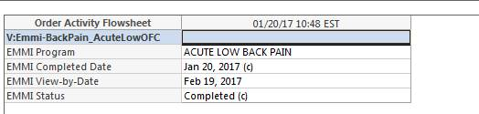

Machine generated alternative text:
EàJh -V-I
Records Returned 1100 Use SpeciFied Dates  1/20/2017 0:00 To 1/20/2017 23:58
Encounter IEMMI. TEST -
Person Alias Encounter Alias HL7 Entity Alias
Contributor System r No Contributor Systems Selected
Status r No Error Status’ Selected
Message Type Message Trigger Clear
Message Control ID I Error Text
Order ID I Event ID
Search
Schedule ID I Accession ID
ESI LOG ID jCONTRI... IC0NTRIBU..IMSJMS... INAME FULL ...IPERSON ID IPERSON ALIAS IENCOUNTER ALIAS IHL7ENTITYALIAS LERROR STAT IERROR TEXT
395675484 GETWELL 749482225 ORU ROl EMMI. TEST 22394533 .810008950, .2983643, .GWN.BAYCARE.F,HNA... ESI_STAT_SUCCESS
395675487 GETWELL 749482225 DRU ROl EMMI, TEST 22394533 .810008950, .2983643. GWN.BAYCARE,F,HNA...__ESI_STAT_WARNING Order Server Reply-- T
395675488 f GETWELL 749482225 ORU ROl EMMI, TEST 22394533 .810008950, .2983643. ,GWN.BAYCARE,F,HNA... ESI_STAT_SUCCESS
395675495 GETWELL 749482225 ORU ROl EMMI, TEST 22394533 .810008950, .2983643. .GWN,BAYCARE,F,HNA... ESI_STAT_SUCCESS ______
Record: iii ilr 1 o14 IHIi I

Successfully received - *Warning Only* due to changing the status from Final to In Process

Machine generated alternative text:
Error Stat ESI_STAT_WARNING
Order Server Reply— The action received by the server could not be processed due to the current state of the order.Transacti on was requested by prsnl_id (1) on person_id (22394533), encntr_id (80096440) to perform
Error Text action_type_cd (2529), order_id (87 61156551), synonym_id (0), catalog_cd (O), catalog_type_cd (1 055699093), encntr_id (0).. error [753664412]: ValidateAction_C omplete: Can complete this order. It’s not in Ordered or
lnprocess status

# **5. Testing**

## 5.1. Unit Testing Scenarios

|  |  |
| --- | --- |
| **Scenario** | **Expected Result** |
| See **Vanja Karabašić** |  |
|  |  |
|  |  |

## 5.2 Integrated Testing Scenarios

|  |  |
| --- | --- |
| **Scenario** | **Expected Result** |
| See **Vanja Karabašić** |  |
|  |  |

## 5.3 Testing Approvals

|  |  |  |  |
| --- | --- | --- | --- |
| **Testing Phase** | **Date** | **Department** | **Team Member** |
| PH1.UNIT |  |  |  |
| PH1.INTEGRATED |  |  |  |

2/2/2017 per **Vanja Karabašić**

Just to let everyone know that after extensive testing of the BMG Orders and EMMI Integration, we have completed the testing and will be ready to move it into production two weeks after education is sent out. The education is still pending but should be completed soon, subsequently we will decide on a Go-Live date once the education has been created.

We have decided to keep the following workflow for the orders:

**Orders are placed:**

C:\Users\b104994\AppData\Local\Temp\msohtmlclip1\02\clip_image001.png

**Order are pending to be watched by the patient:**

C:\Users\b104994\AppData\Local\Temp\msohtmlclip1\02\clip_image002.png

**Patient completed watching video/orders:**

C:\Users\b104994\AppData\Local\Temp\msohtmlclip1\02\clip_image003.png

**Results display:**

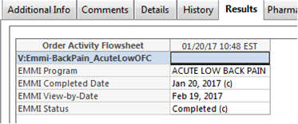

## 5.4 Piloting

NA

## 5.5 Approvals - Please see Monica Bousbar in the Lab

|  |  |  |  |
| --- | --- | --- | --- |
| **Testing Phase** | **Date** | **Department** | **Team Member** |
| PH1.0 |  |  |  |
|  |  |  |  |
|  |  |  |  |

# 6. Deployment / Implementation Model

***GO LIVE*** xx/xx/2017

# Appendix A: Risks and Concerns

|  |  |  |  |  |  |  |  |  |
| --- | --- | --- | --- | --- | --- | --- | --- | --- |
| **Project Name** |  |  | | |  |  |  |  |
| **Number** | **Risk / Concern** | **Comment** | **Mitigation** | | |  |  |  |
| RC.2013.1.0 |  |  | |  | |  |  |  |

# Appendix B: Issues List

This is a dynamic list of the open issues related to the IDBB that remain to be solved, including but not limited to TBDs, pending decisions, information needed, conflict awaiting resolution, and the like.

|  |  |  |  |  |  |  |  |  |
| --- | --- | --- | --- | --- | --- | --- | --- | --- |
| **Project Name** |  |  | | |  |  |  |  |
| **Number** | **Issue** | **Comment** | **Fix** | | |  |  |  |
| I.2013.1.0 |  |  | |  | |  |  |  |

* End of document